**EMPOWERMENT PATHWAY PREVENTING PRESSURE INJURY**

**MAIN OBJECTIVES:**

1. Determine the prevalence of pressure injuries (PI) in cardiac surgery (including perioperative ICU and post-ICU) to identify the scale of the problem and facilitate broader application (e.g., national guidelines). Also, to evaluate potential issues when implementing the SEM scanner into hospital procedures and medical staff training.
2. Assess the ease of using SEM and gather feedback from nursing staff on the device’s usefulness and impact on their work.
3. Digitize medical documentation and increase the reproducibility and objectivity of the assessment
4. Determine the impact of SEM scanner implementation on preventive procedures, patient quality of life, complications, length of hospital stay, and pharmacoeconomic aspects and so on
5. Identify potentially modifiable risk factors for early onset of pressure injuries after cardiac surgery (e.g., patient positioning on the operating table, use of heating mattresses, additional positioning mattresses such as vacuum mattresses).

**STUDY POPULATION: CARDIAC SURGERY PATIENTS 2023**

* Total operated: 2395
* Bedsores: 150 (6%)
* Planned study population: 500 patients undergoing “low-risk” procedures for bedsores (euroscore, patient mobility).
* Recruitment by patient informed consent to participate; invitation to all patients at admission.

**INCLUSION CRITERIA:**

* No visible bedsores upon admission

**STUDY DESIGN:**

* Prospective observational study
* 15 months + 3 months for data analysis
* Dissemination milestones at month 9, 12, 15 and 18 to inform and influence stakeholders (professional groups, policy makers, professional training bodies, practitioner alliances)

**INTERVENTION:**

* Implementation of pressure ulcer prevention base on SEM scanner procedure versus standard procedure

**PHASE ONE – "Training" (3 months):**

* period without SEM as a decision-making factor, training only
* Time to assess compliance and acceptance of the new equipment by staff, which may indicate the need for additional training or procedural modifications.
* During this phase, the scanner is not used in the decision-making tree, but only for comparison purposes with clinical assessment
* Duration: january - march 2025 (3 months)

**PHASE TWO**

* Period WITH SEM scanner in the decision-making tree. New hospital procedure based on SEM. Assess the impact of early prevention on economic aspects.
* Duration: April - December 2025 (9 months with scanner).
* Comparing the period before scanner use with the period after scanner use.

**Data Collection on both phases:**

* Characteristics of the patient group (identifier necessary for document analysis, age, gender, body weight, height, comorbidities, continence, nutritional status assessment, NRS, surgery/procedures/treatment applied)
* Pressure injury risk assessment at various time points according to hospital procedure

Proposed time points for patient assessment (possible modification during the course of the study)

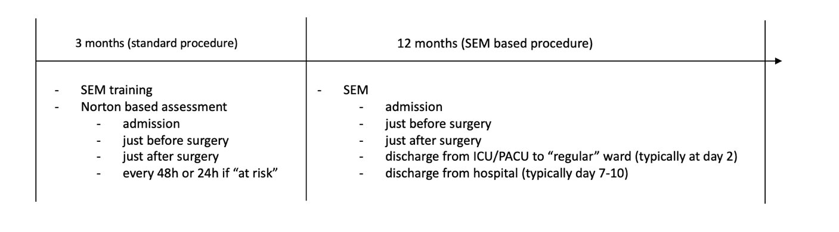*every patient has an anti-decubitus mattress after surgery, when the patient is discharged from the ICU/PACU to the regular ward, a decision will be made (depending on the phase of the study based on the norton scale or the SEM scanner) about further prophylaxis. In addition, the SEM scanner will give the opportunity to REDUCE patient risk assessments from currently every 48h to every 3-5 days (de facto at discharge according to SEM procedure).

**Data Analysis:**

* patient comfort assessment
* assessment of the device’s ease of use and its impact on the time required for existing procedures
* Assessment of equipment usage and working time
* Total cost of patient care during the hospital stay
* Evaluation of the usefulness of selected time points – possible modification in final procedure

**STATISTICS**

Comparison of results from before the use of the scanner (3 months) to after the use of the scanner (9 months).

Based on an analysis of the data distribution (e.g. t-student, Mann Whittney, Friedman test/Conover's post hoc analysis, logistic regression, Kaplan Meier estimator, Propensity)

**STUDY SUPPORT AND ACADEMIC LINKS**

Górnoslaskie Centrum Medyczne is part of the Silesian Medical University in Katowice (GCM) with access to support from faculties of medical science, heath science and public health.

There is potential to engage PhD studentships through these academic links, and to engage with university initiatives in virtual patient/virtual reality teaching methods; inform university modern teaching tools for student professionals.

Through these links Górnoslaskie Centrum Medyczne will seek representation on a Research Advisory Group for EPPPI.